Amanda Bakalarczyk

COSC 2406

Assignment 4

2017-20-27

A)

TITLE {A} (A.asm)

;Program reads data from file traverses indexes and locates characters in their correct ;sequence to form a message

;Amanda Bakalarczyk

;Assignment 4

;Problem A

;2017-10-27

B)

TITLE {B} (B.asm)

;Program asks the user for a lower number and an upper number.

;Procedure generates a random number from the lower number to upper number.

;Amanda Bakalarczyk

;Assignment 4

;Problem B

;2017-10-25

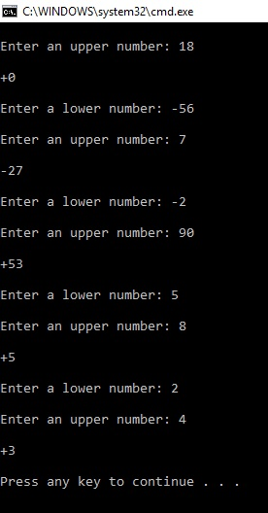

C)

TITLE {C} (C.asm)

;Collection of separate procedures which fill an array with random numbers

;displays array, sum of values, count of positive values, and largest number

;Amanda Bakalarczyk

;Assignment 4

;Problem C

;2017-10-25

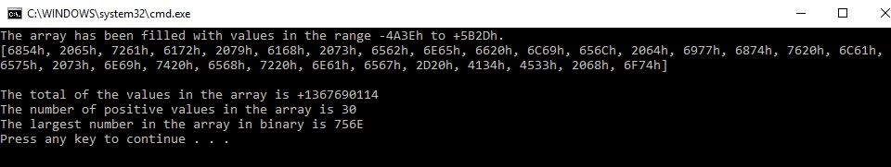

D)

TITLE {D} (D.asm)

;Program calculates the sum(n) using a procedure which accepts n as a value in eax

;returns the answer, sum(n) in the same register.

;Amanda Bakalarczyk

;Assignment 4

;Problem D

;2017-10-26

